**Website: Maghazi Community Rehabilitation Society**

Maghazi Community Rehabilitation Society is a charitable, non-profit Palestinian civil society organization. We created this website in 2021, using HTML, CSS and jQuery, also template (smash-template-opl). The pages in this website, is:

* **Contact Us:**

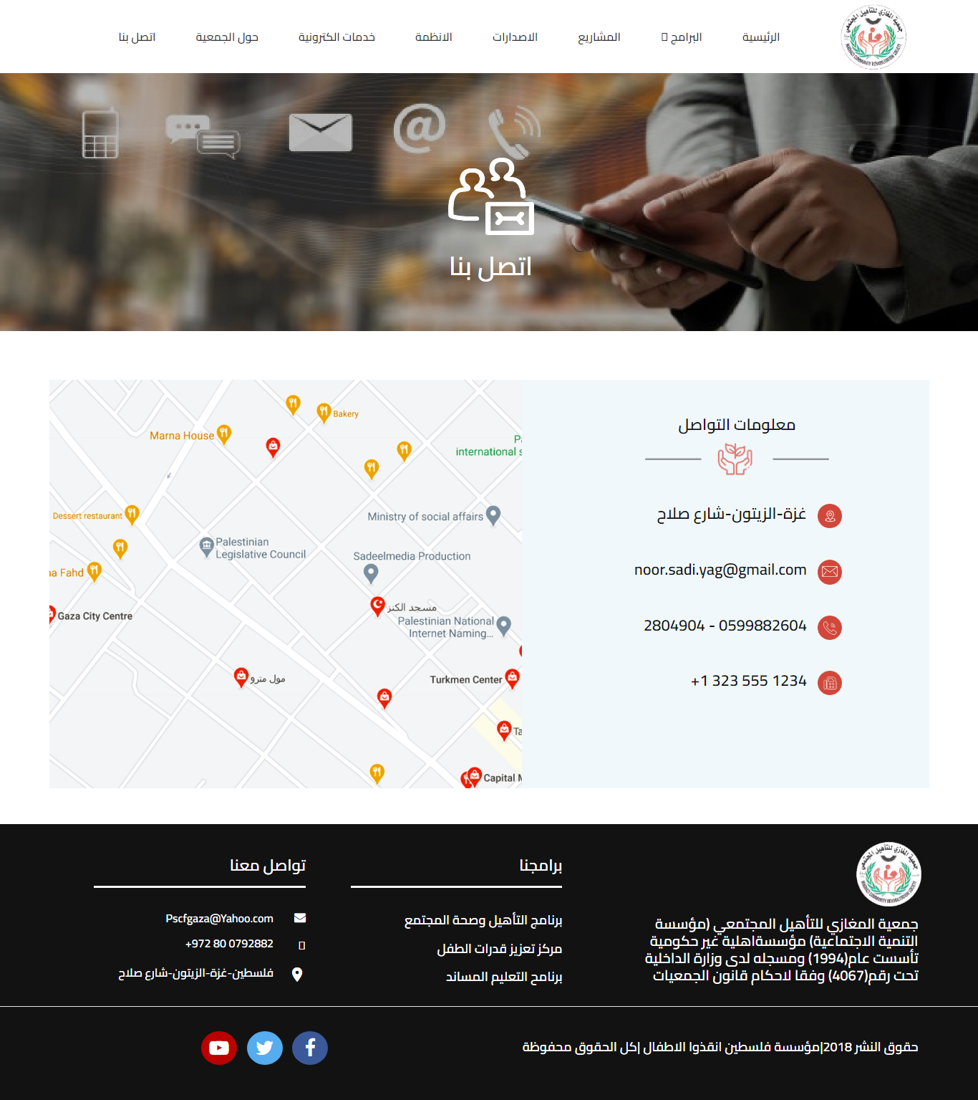

* Home:

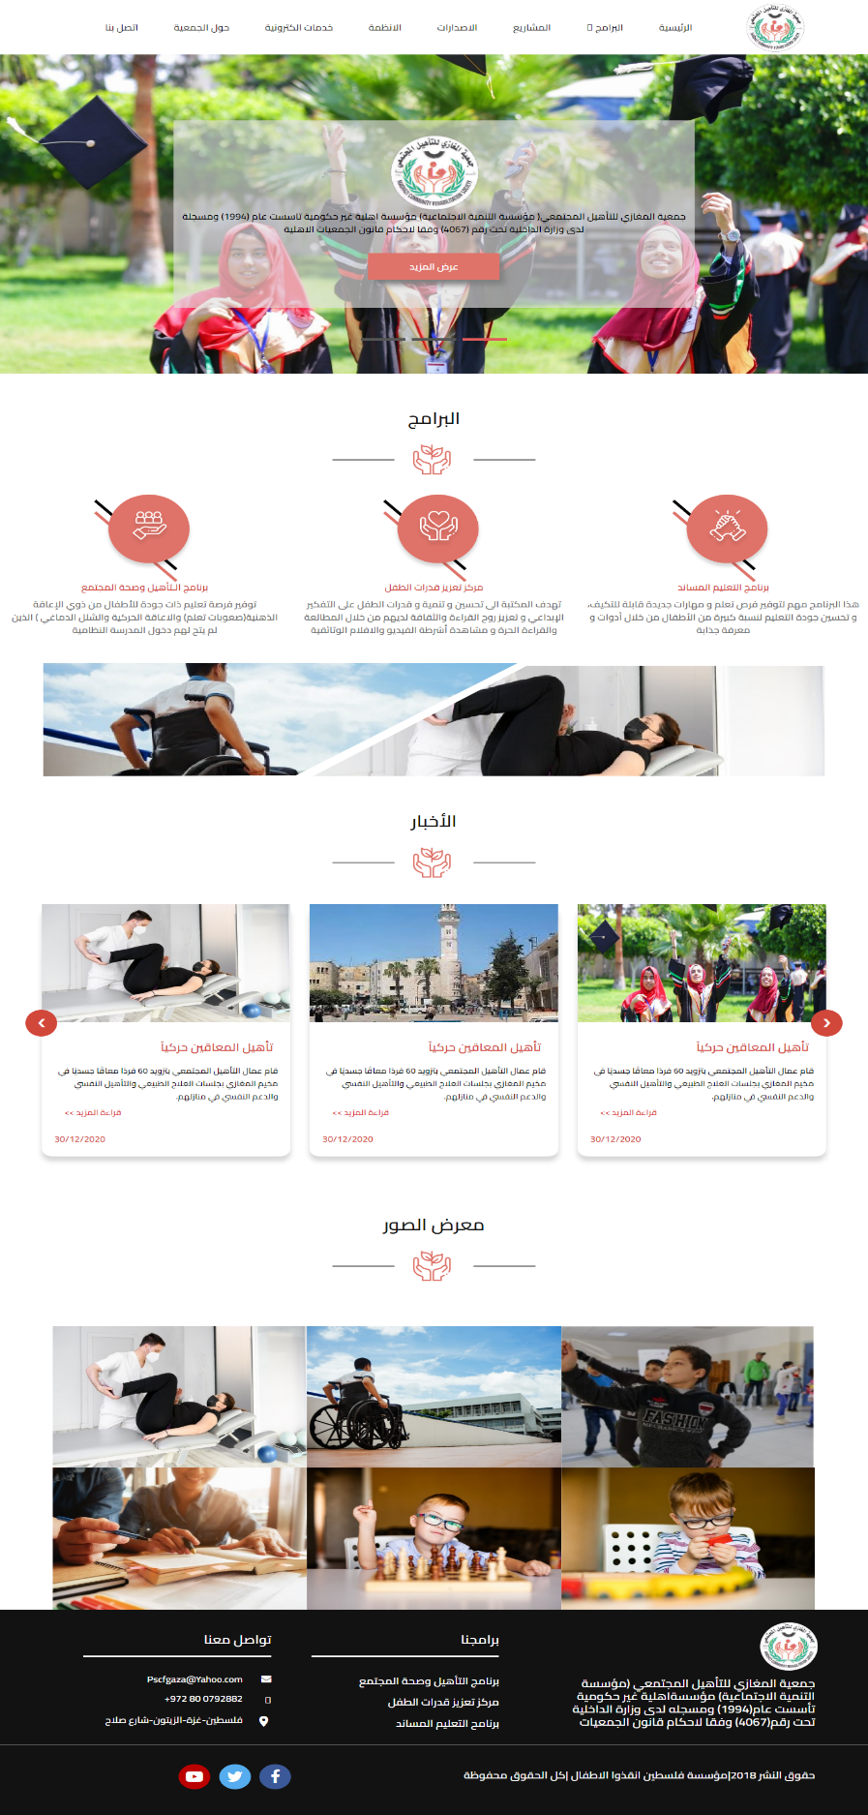

* About:

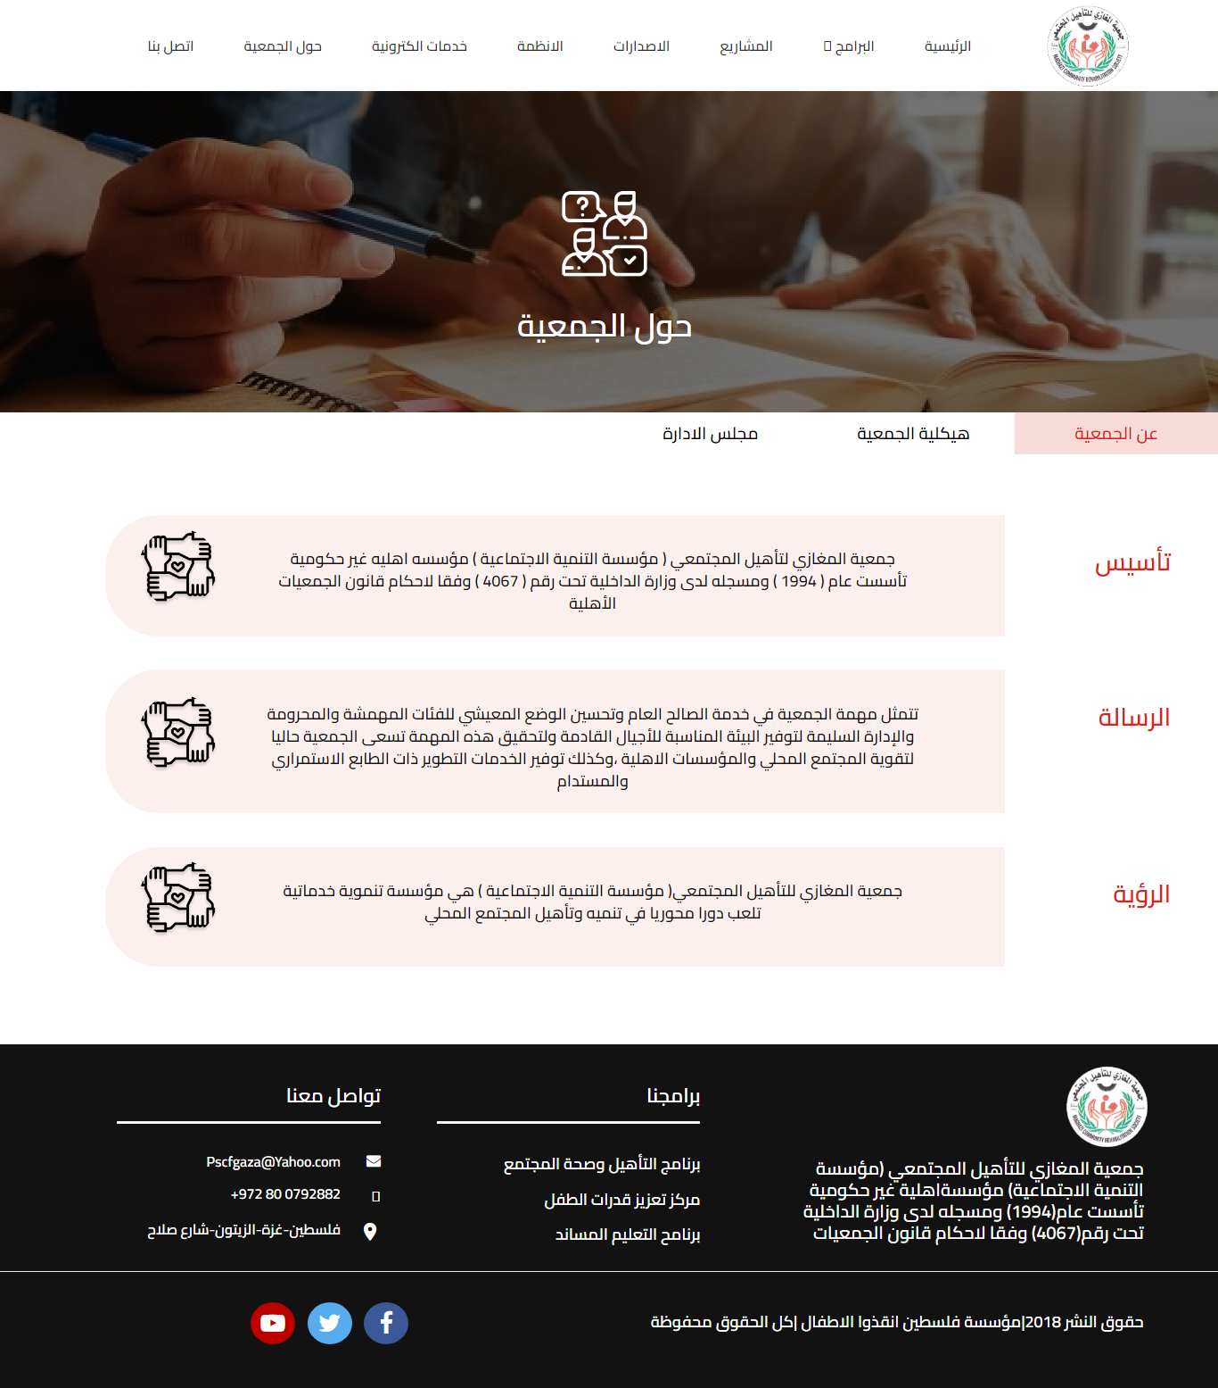

* Education programs:

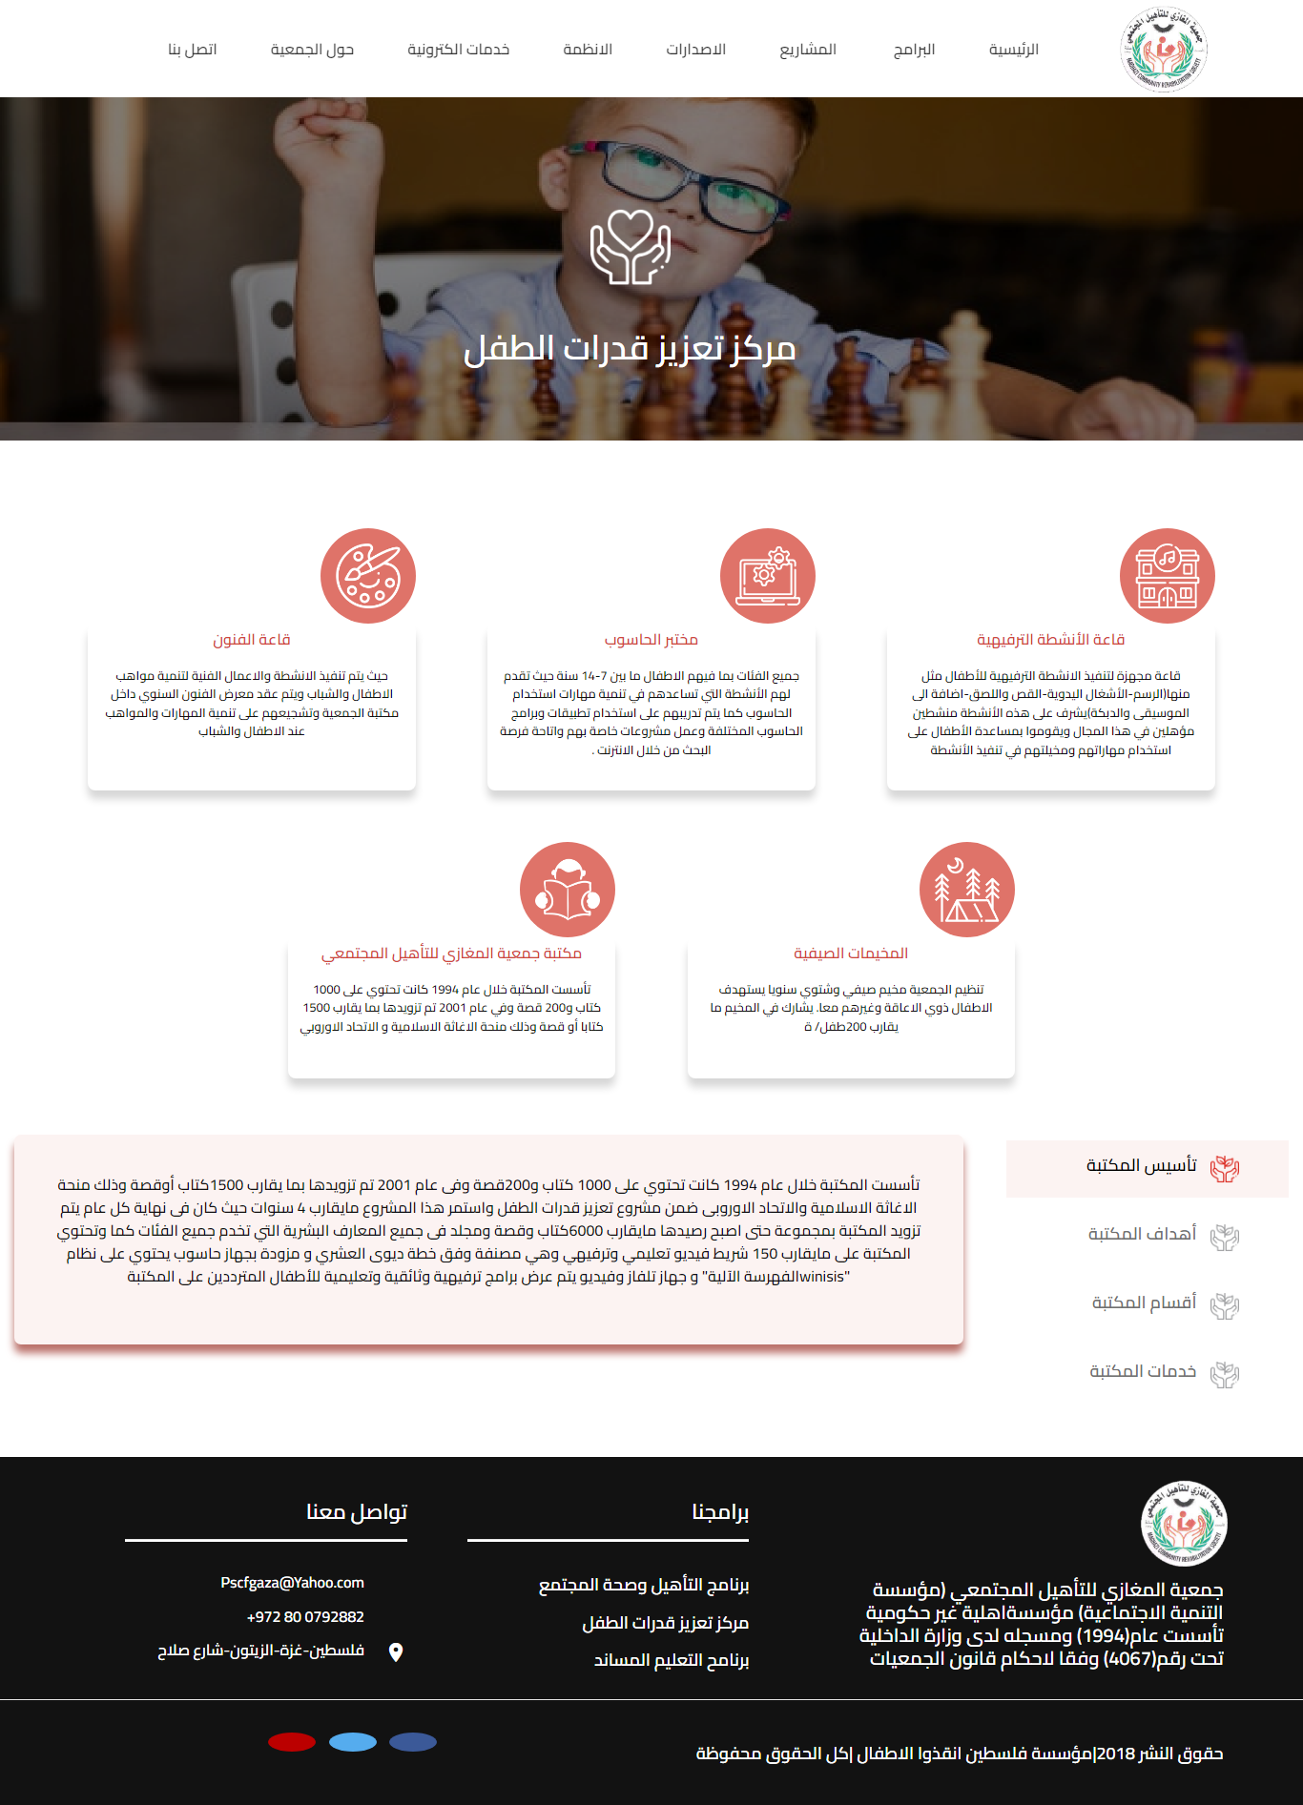

* Projects:

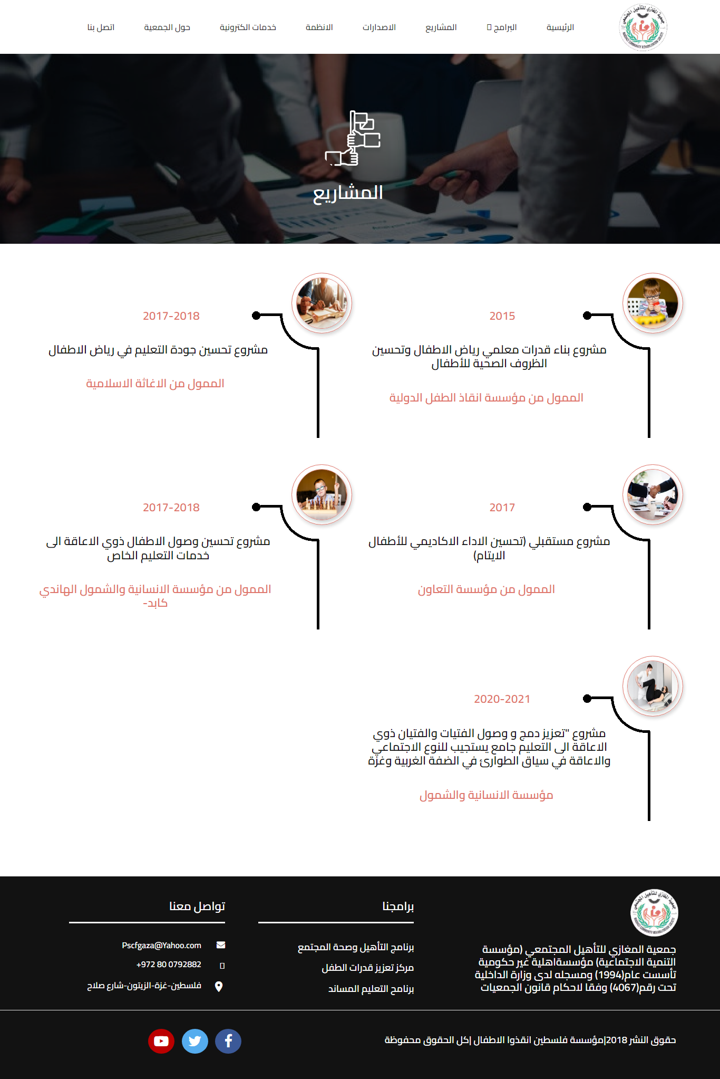

* Reports file:

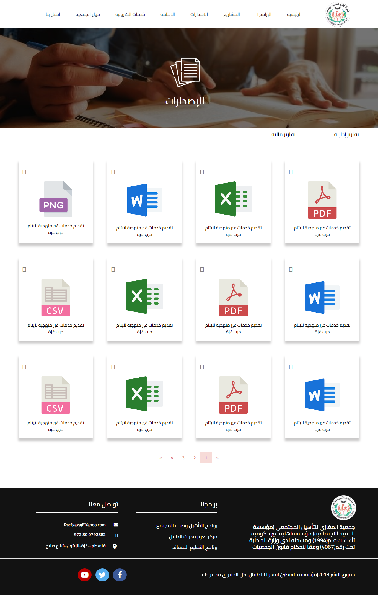

* Complaints

